Week 1 - Logging using SLF4J
Exercise 1: Logging Error Messages and Warning Levels
pom.xml:
<?xml version="1.0" encoding="UTF-8"?>
<project xmlns="http://maven.apache.org/POM/4.0.0"
xmlns:xsi="http://www.w3.org/2001/XMLSchema-instance"
xsi:schemaLocation="http://maven.apache.org/POM/4.0.0 http://maven.apache.org/xsd/maven-4.0.0.xsd">
<modelVersion>4.0.0</modelVersion>

<groupId>com.aditya</groupId>
<artifactId>junit-testing</artifactId>
<version>1.0-SNAPSHOT</version>

<properties>
<maven.compiler.source>17</maven.compiler.source>
<maven.compiler.target>17</maven.compiler.target>
<project.build.sourceEncoding>UTF-8</project.build.sourceEncoding>
</properties>

<dependencies>
<dependency>
<groupId>junit</groupId>
<artifactId>junit</artifactId>
<version>4.13.2</version>
<scope>test</scope>
</dependency>

<dependency>
<groupId>org.mockito</groupId>
<artifactId>mockito-core</artifactId>
<version>4.11.0</version>
<scope>test</scope>
</dependency>

<dependency>
<groupId>org.slf4j</groupId>
<artifactId>slf4j-api</artifactId>
<version>1.7.30</version>
</dependency>

<dependency>
<groupId>ch.qos.logback</groupId>
<artifactId>logback-classic</artifactId>
<version>1.2.3</version>
</dependency>
</dependencies>
</project>

Solution Code:
LoggingExample.java:
import org.slf4j.Logger;
import org.slf4j.LoggerFactory;

public class LoggingExample {
private static final Logger logger = LoggerFactory.getLogger(LoggingExample.class);

public static void main(String[] args) {

logger.error("This is an error message");

logger.warn("This is a warning message");
}
}
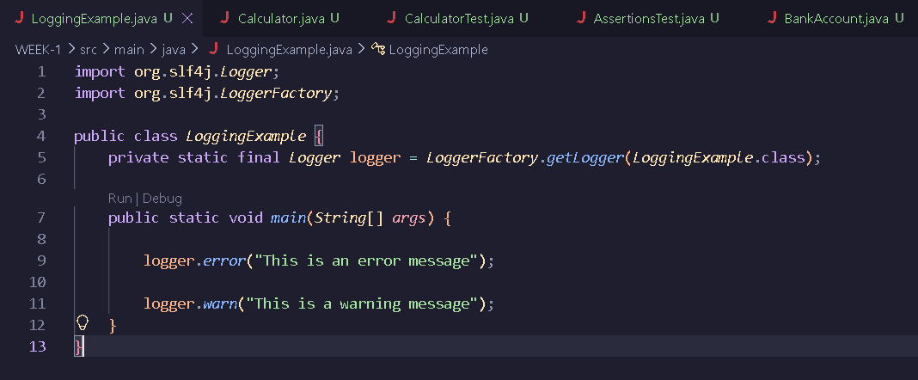

Output:
